MASARYK UNIVERSITY

CEITEC

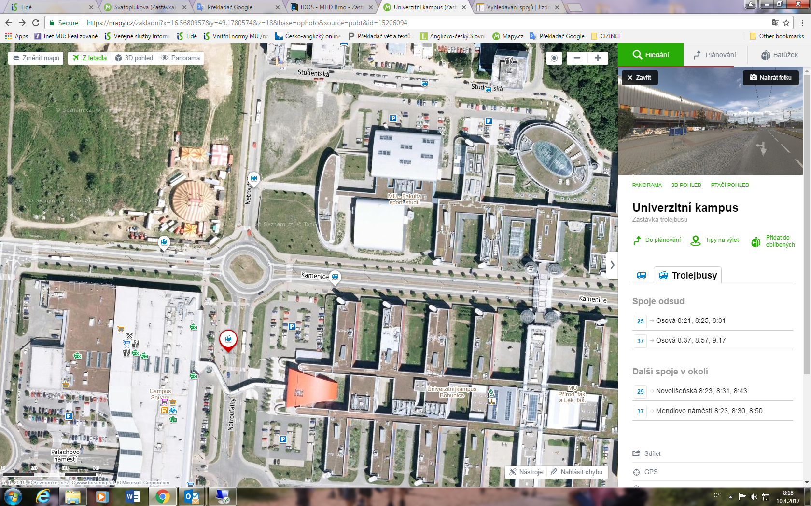

CEITEC, build # 35

The main entrance to Masaryk University, build # 22

Trolley stop to Unihotel Čejkova

Shopping center TESCO

Trolley stop to Univerzitní Kampus