THE ENVIROMENTAL DEPARTMENT - WASTE COLLECTION FEE
THE ENVIROMENTAL DEPARTMENT
Address: Šumavská 35, Building C, 3th floor
Business days:
Monday, Wednesday: 8:00 – 17:00 and Friday: 8:00 – 12:00
Telephone: 542 174 301, 542 174 313
E-mail: odpady@brno.cz

Local public transport:
- from Main train station by tram no. 12 to Technologický park, bus stop Klusáčkova
- from street Brandlova (terminus Česká) troleybus no. 34 to Žabovřesky Vychodilova, bus stop Klusáčkova
- from street Brandlova (terminus Česká) troleybus no. 36 to Komín sídliště, bus stop Klusáčkova
WASTE COLLECTION FEE
WHO PAYS?
All foreign citizens who intend to stay in Brno for longer than 3 months have the responsibility to pay the waste collection fee. The fee needs to be paid by May 31 (if you arrive before May 31) or within 15 days after the commencement date (if you arrive after May 31). Detailed description is also available at the City of Brno web pages.
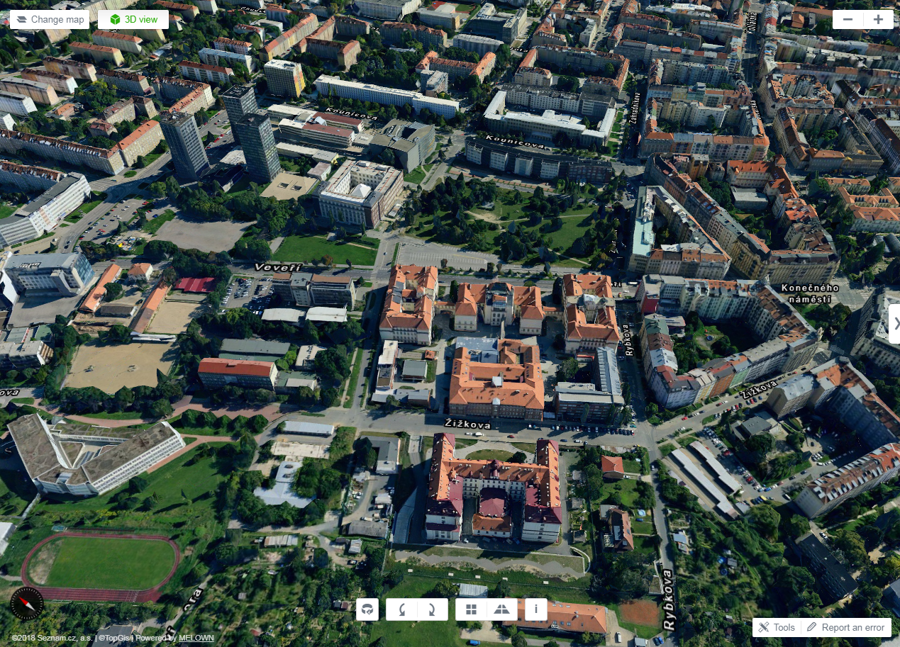
Veveří street
Center Brno
Kounicova street
Konečného square
High building: the Environmental Department
address: Šumavská 35, Building C, 3th floor

