AIRPORT TUŘANY - BRNO
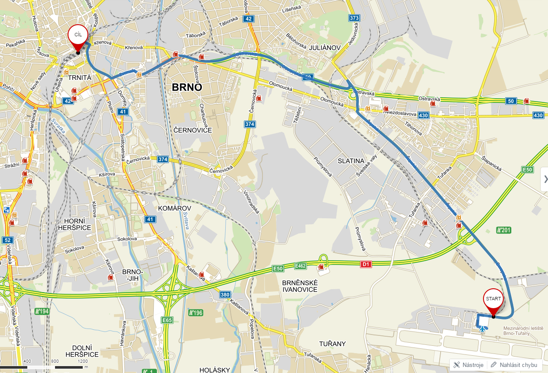
Airport

Brno Main Train Station

FROM THE AIRPORT use the city bus # E76 and go about 15 minutes to its final stop - Brno Main Train Station. You need to buy a ticket for 25 CZK - 1 € at the counter in the departure hall or at the vending machines in the arrival hall.

