How to get to the Immigration Office in Brno?
How to get to the Ministry of the Interiot “MOI” (Department for Asylum and Migration Policy – “OAMP” Immigration Office ):
Address: Hněvkovského 65
Office Hours: Monday + Wednesday: 8am – 5pm, Tuesday + Thursday: 8am – 2pm
Friday is closed unless you have been invited for interrogation.
Appointment may be scheduled at 543 213 313.
By bus: there is a bus stop Hněvkovského right in front of the gate to the alley leading to the Immigration office.
Buses no. 40, 48, 59, 67, /tram 12/ leave from Úzká (in front of Vaňkovka shopping mall or the tram stop #12)
By tram: tram no. 12 to the terminal stop Komárov. Then take one of the busses mentioned above from Komárov bus stop or 10min walk down the Hněvkovského street.
By car: there is a parking lot right pass the gate to the alley leading to the the Immigration Office.

Detail map
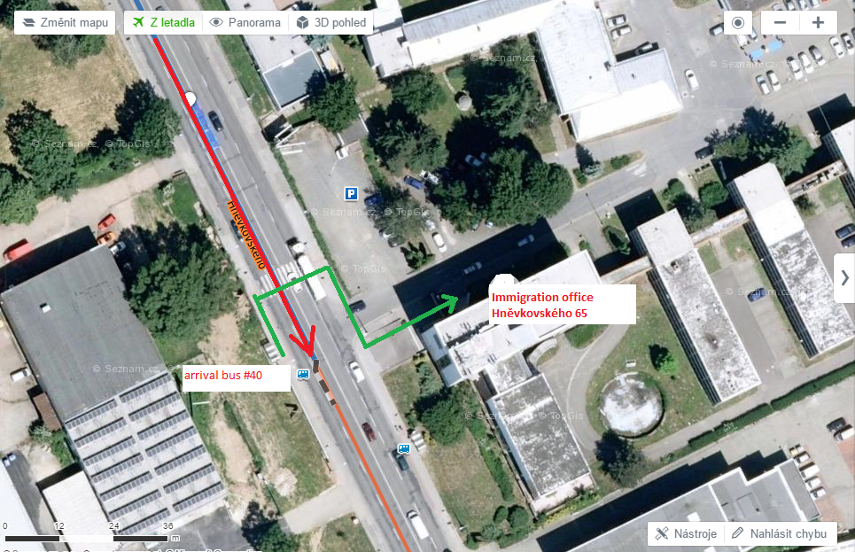
Bus to the center
OAMP

