CHECK LIST
for Foreign Employment (long-term residence permit over 90 days)

More information and all the mentioned documents can be found on our website https://www.ceitec.eu/welcome-service/t9794

BEFORE ARRIVAL

- Visa/ Residence permit for non-EU/EFTA nationals:
You must not enter the Czech Republic until you have received your visa or been approved for a residence permit. Not to be confused with a tourist visa.Clarify kind of entry permit and immigration requirements.
For further information read:
https://www.mzv.cz/jnp/en/information_for_aliens/long_stay_visa/long_stay_visa.html

Make sure you have following documents:
- Valid passport
- Supporting documents (Hosting Agreement, Obligation of the Organization, Contract of Employment, Confirmation of monthly income, etc.)
- Criminal record(s)
- Proof of accommodation (if required)
- Proof of travel insurance
- Passport photos (2pcs)

- Residence permit for EU/EFTA nationals
To enter the Czech Republic visa/assurance of a residence permit is not required.

- Finding accommodation or temporary solution

- Inform yourself of childcare and preschool and school facilities for kids

- Practicalities
- Check insurance and terminate if necessary
- Clarify possible tax liability in your home country
- Notice of departure at you place of residence
- Sign off services (energy, telephone, etc.)
- Mail redirection

AFTER ARRIVAL

- Visa/ Residence permit orf non-EU/EFTA nationals
Registration of one´s residence stay in the CR – must be done within 3 days after arrival.
Address: Department of Asylum and Migration Policy Brno (Counselling desk at 2nd floor)
Hněvkovského 30/65, 617 00 Brno
- Fill in the form (green application)
- Valid passport
- Supporting documents - Contract of Employment, Confirmation of monthly income
- Proof of accommodation
- Proof of mandatory health insurance
- Passport photos (2pcs)

- Residence permit for EU/EFTA nationals
Registration of one´s residence stay in the CR – must be done within 30 days after arrival.
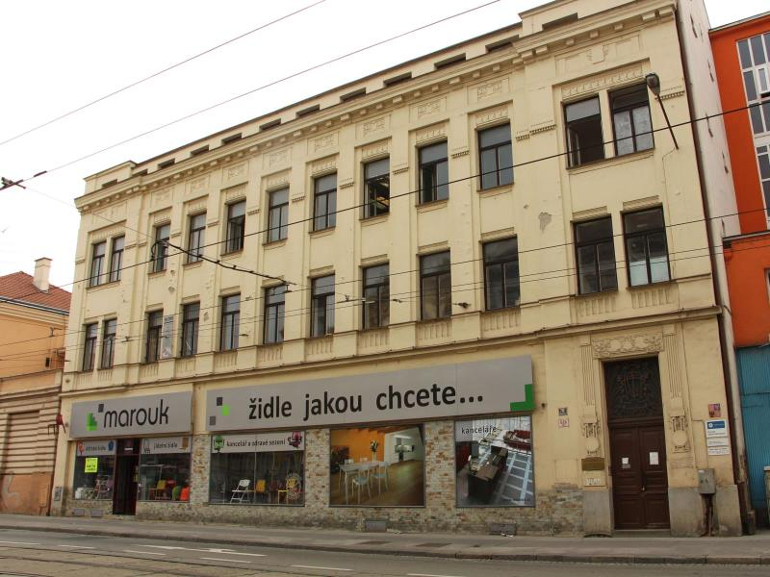
Address: Foreign Police, Cejl 62b, 602 00 Brno
- Fill in the short questionnaire
- Valid passport
- Proof of accommodation

- Practicalities
- Pre-school / school facilities
- Open bank account
- Register your vehicle
- Change of the driving license (if required)
- Municipal Transportation
- Mobile phone operator
- Integration issue
- Family, Medical care

BEFORE DEPARTURE

For all foreign employees:

- Close a bank account (since we need to send you your wage, please close your account earliest 30 days after your departure)
- Return the employee card and health insurance card to HR department
- Return residence card – send it to the Department of Asylum and Migration Policy Brno by mail
- Pay all bills and leave accommodation

