**EXCHANGE OFFICE**

On Masaryk street (red line), there are many Exchange offices.

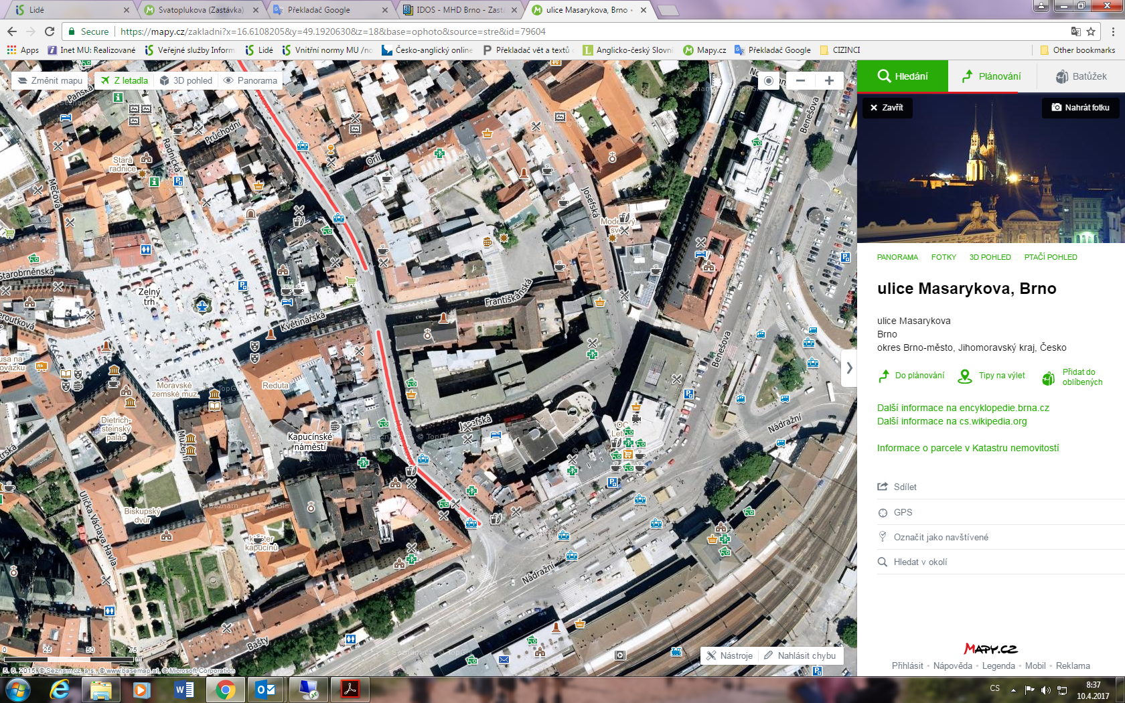

Student Agency

Tram # 2

Main tran station