THE KOMÁROV HOTEL - https://www.skm.muni.cz/hotel/komarov?en
Accommodation in a calm area of Brno, at the university halls of residence, in the proximity of the Olympia and Avion shopping centers. There are 17 beds available all year round in twin or triple rooms with sanitary facilities and a TV and a shared kitchen on each floor. Wired Internet connection is available in each room. pevného internetové připojení a WiFi eduroam.
The capacity is limited during the academic year.
Parking of cars or buses in front of the hotel.

How to find us
The connection from the main train station by bus No. 40, 48, 49, 50, 63, 67, or from Tesco, Brno - Úzká by bus No. 40, 48, 50, 63 - Komárov stop. Direct connection from the University campus by bus No. 50 - find on the map

Booking for MU guests
Rozsypalová Yveta: 549 49 2724
e-mail: hotel.komurov@skm.muni.cz
Contact information
Address: bří. Žůrků 591/5, 617 00 Brno – Komárov
Reception: 549 49 2715
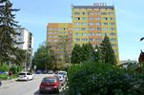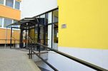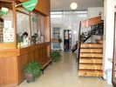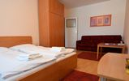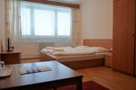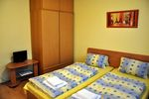

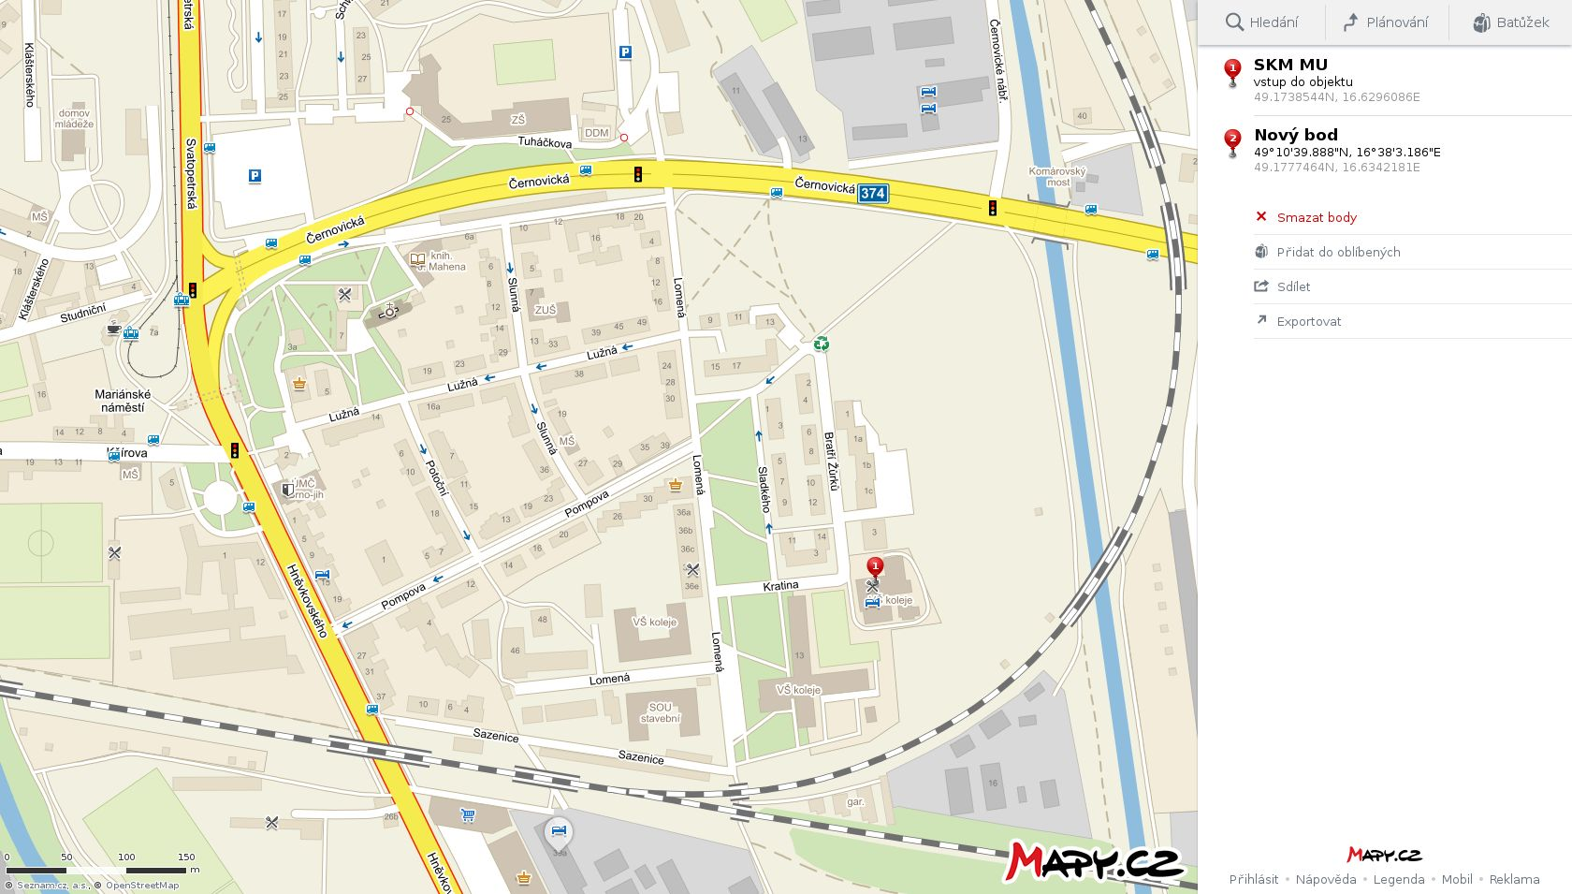

BRNO CENTRE

The Komárov Hotel

Booking for MU guests
Rozsypalová Yveta: | 549 49 2724
e-mail: | hotel.komarov@skm.muni.cz

Contact information
address: | bří. Žůrků 591/5, 617 00 Brno - Komárov
reception: | 549 49 2715

How to find us
The connection from the main train station by tram No. 12, or from Tesco, Brno - Úzká by bus No. 40, 48, 63 (Komárov stop). Direct connection from the University campus by bus No. 50

BUS STOP #40,48,63
BUS STOP # 50
THE KOMAROV HOTEL
TRAM STOP # 12

