The Grohova UNI Hotel - https://www.skm.muni.cz/hotel/uni-grohova?en

A newly reconstructed house in the center of Brno in the immediate vicinity of the Faculty of Arts of Masaryk University used mainly for long-term stays of foreign MU lecturers. There are four flats 1+kk (1 room + kitchen unit) and five flats 2+kk (2 rooms + kitchen unit). The flats are fully equipped. There is a cable TV and a possibility of wired Internet connection a WiFi eduroam. There is a laundry room available for the guests.

Contact information:
address: | Grohova 108/11, 602 00 Brno
The rooms are cleaned once a week with the exchange of bed linen every two weeks. There is no reception service in the building; accommodation is possible only by prior appointment. There is no reception service in the building.

How to find us: In the vicinity of the MU Faculty of Arts.

Connection by tram No. 12 from the main station and tram No. 3 and No. 11 from Česká street - find on the map

Information and bookings: Šoustalová Helena: 549 49 8291, e-mail: uni.grohova@skm.muni.cz
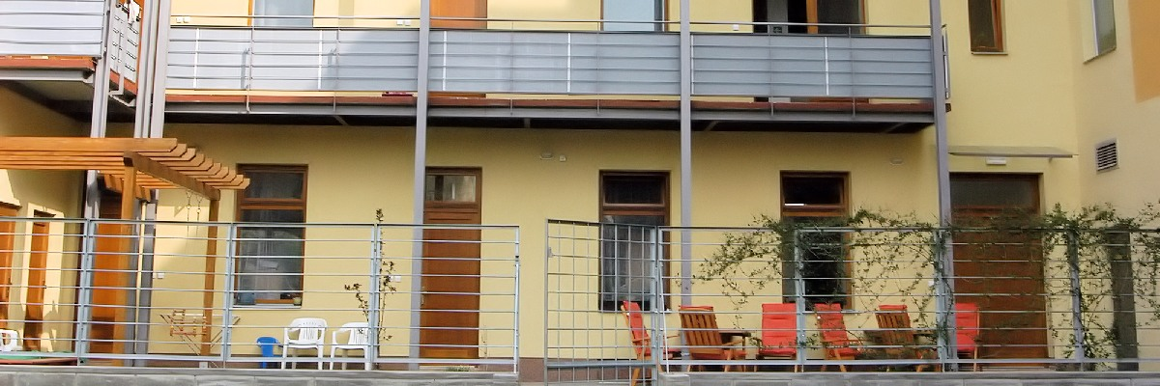 |  | 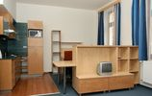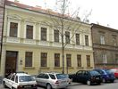

The Grohova UNI Hotel

Information and bookings
Šoustalová Helena: | 549 49 8291
e-mail: | uni.grohova@skm.muni.cz

Contact information
address: | Grohova 108/11, 602 00 Brno

How to find us:
In the vicinity of the MU Faculty of Arts. Connection by tram No. 12 and 13 from Česká street (Grohova stop)

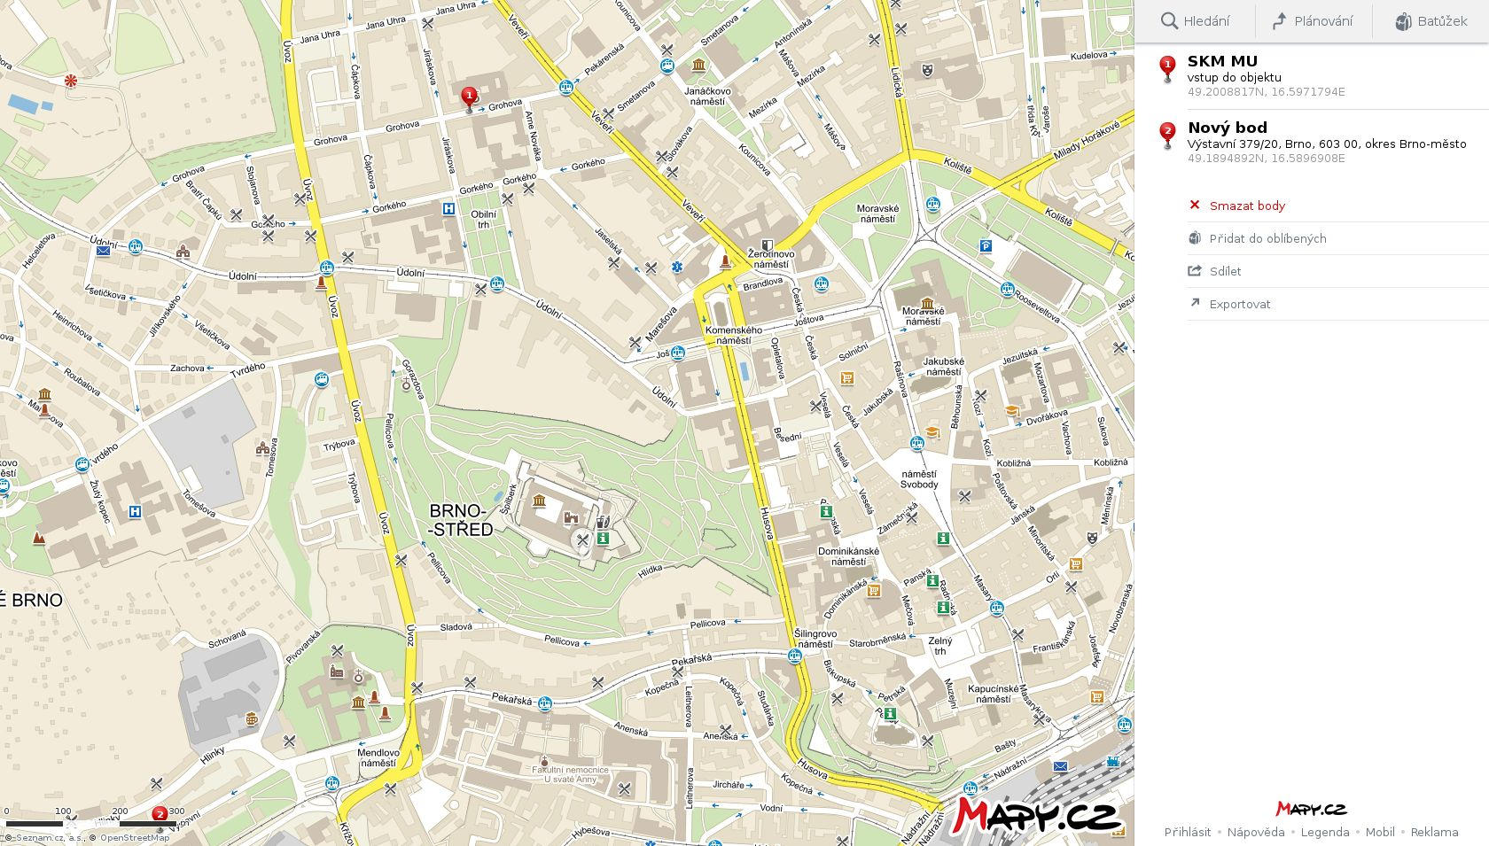
TRAM STOP ČESKÁ # 12, 13
BRNO CENTRE

THE MAIN TRAN STATION

THE GROHOVA UNI HOTEL

TRAM STOP GROHOVA # 12

