Document Photos (passport photo)
A photograph is rectangular, measuring 35 mm x 45 mm, standing on the shorter side.
The photograph shows the head and upper part of the shoulders of the person.
The expression must be neutral with the mouth closed and the eyes open. Hair should not cover the face.

CEWE FOTOLAB Address: Kamenice 745/1, 625 00 Brno
(5 minutes from University Campus Bohunice)

AZ FOTO Address: Zvonařka 470/2b, 602 00 Brno-město (next to shopping center Vaňkovka)

CEWE FOTOLAB Address: Kobližná 11, 602 00 Brno
(in the center near the Svoboda Square)
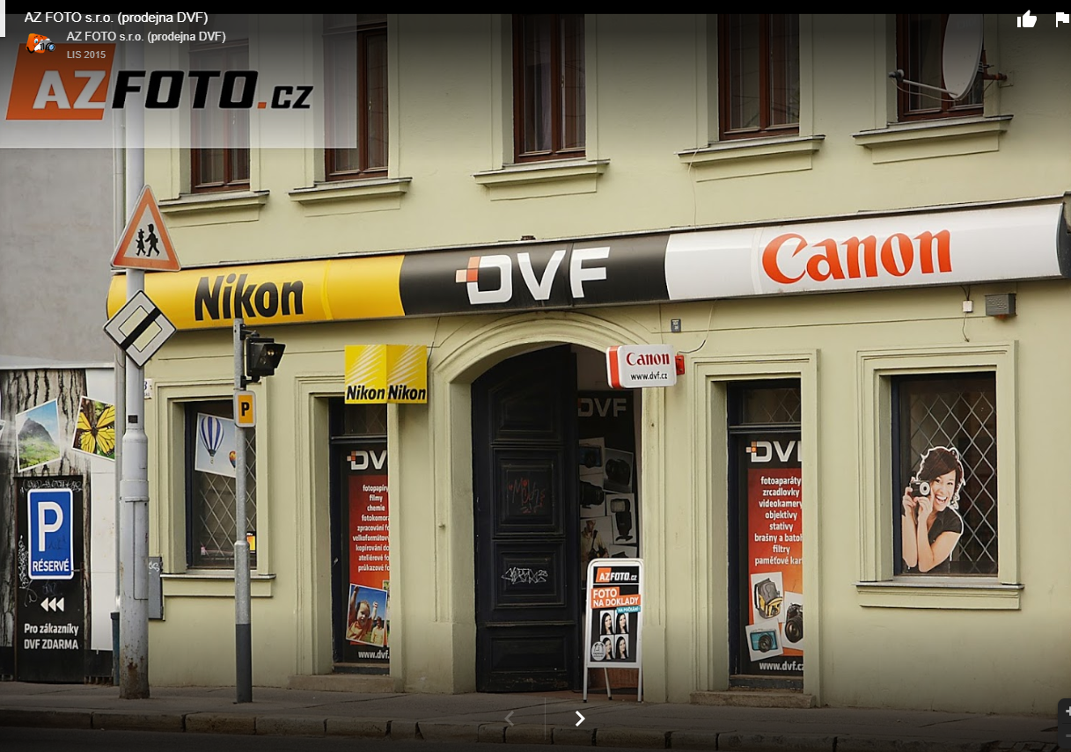

AZ FOTO s.r.o. (shop DVF) Address: Pekařská 442/88, 602 00 Brno-center
(near the Mendlovo Square)

