How to Get to Brno
This page contains information on how to get to Brno from Prague and Vienna airports, how to get to the city centre from Brno airport, and the bus and railway stations. Other useful links are listed below.
IMPORTANT INFORMATION
Long-term train diversion in Brno: most trains do not arrive/depart from the main railway station ‘Brno hlavní nádraží.‘ Trains from and to Prague, Vienna, and Budapest stop at ‘Brno dolní nádraží‘ and ‘Brno-Židenice‘ stations. If you are traveling to Brno by train, please ask your ESN buddy to pick you up at Brno dolní nádraží or Židenice station. In case you do not have a buddy yet, apply for one! We would recommend you to get off at Brno dolní nádraží and take the replacement bus n°61 that runs between Brno dolní nádraží and Brno hlavní nádraží. Czech Railways and Regiojet tickets are valid on this line.

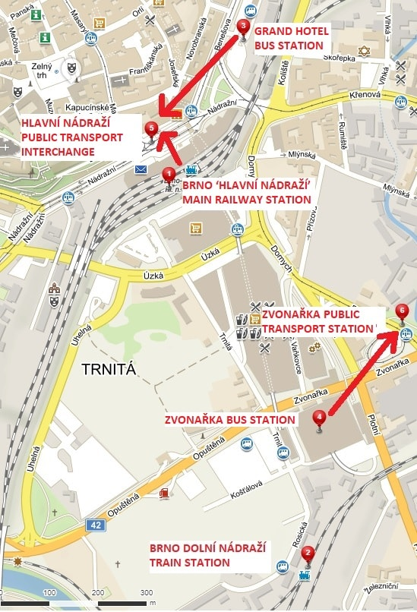

1. HOW TO GET TO BRNO FROM PRAGUE OR VIENNA AIRPORT

FROM PRAGUE BY BUS
There are several bus companies operating buses from Prague to Brno. The yellow Student Agency (RegioJet) buses also leave directly from Prague’s Vaclav Havel airport (you will have to change buses at the main bus station Florenc in Prague, but one ticket is valid for the whole journey by both buses). There is a ticket office of the Student Agency at Terminal 1 in Prague. You can buy your ticket in advance and pay by credit card – it is really easy. Flixbus, Eurolines, and other companies operate buses from the bus station Florenc – you can get there by another bus operated by Student Agency or ask for directions at the airport. Student Agency and Flixbus will drop you off at the Grand Hotel bus station in Brno, while other companies usually stop at Zvonařka bus station.

FROM PRAGUE BY TRAIN
To get to Brno by train, you will first need to get to Prague’s main railway station – you can go by Airport Express, or buy a special bus + train ticket directly to Brno, go to the railway station by public transport or ask for the directions at the airport. You can buy your ticket online on the website of the České dráhy company or at the railway station. Student Agency/Regiojet also offers a combined bus + train ticket directly from the airport. Please do not forget to count at least 2 hours extra time to get to the railway station from the airport – it does not take that long, but since you do not know the way, you must count some extra time to find it and time to buy the ticket at the railway station to be on the safe side!
- Plan of Vaclav Havel Airport
- Interactive clickable plan of Florenc Coach Station – the main bus station in Prague
- You can check the bus and train schedules online here, switch it to English (bottom right corner). The yellow “buy” button will redirect you to the e-shops of the most bus and railway companies.

FROM VIENNA BY BUS
Student Agency and Flixbus operate direct buses from Vienna’s Schwechat airport, and both stop at the Grand Hotel bus station in Brno. LEO Express leaves from the airport but stops at Zvonařka bus station. Other buses leave from bus stations in Vienna – ask for directions at the airport. You can check their schedules and buy tickets online here.

FROM VIENNA BY TRAIN
You can also travel from Vienna airport by train – there is a railway station in front of the arrivals hall. You can check the schedules and buy your ticket online here. Type Flughafen Wien in the “From” field and Brno hl. n. in the “To” field. You will have to change trains at Wien Hauptbahnhof and possibly in Břeclav as well.
- Plan of Vienna Schwechat Airport

2. HOW TO GET TO THE CITY CENTRE FROM BRNO AIRPORT OR OTHER STATIONS

FROM BRNO AIRPORT
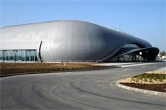From some destinations, there are direct flights to Brno Airport
Taxi service from the airport – offered by the Foreigners.cz agency. It is highly recommended to order a taxi at least one day before (Online ordering here). A price list and order form can be found here.
Public transport – bus E76 (every 30 minutes) or N89 (at night). Both will take you to the “Hlavní nádraží” stop. You can continue to your dormitory from there. You can check bus timetables online here. Switch the page to English (bottom right side) and type Letiště Tuřany – terminál in the “From” field and Hlavní nádraží in the “To” field. The journey takes around 20 minutes, but don’t forget to buy a ticket at the airport.

FROM THE MAIN RAILWAY STATION (HLAVNÍ NÁDRAŽÍ)
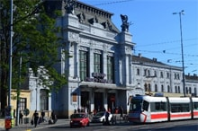
If you are coming to the main railway station – Brno hlavní nádraží, you will only have to get to the public transport stop “Hlavní nádraží” located in front of the building (see the map above). Check how to get to your dormitory section below.

FROM THE GRAND HOTEL BUS STATION (AUTOBUSOVÉ NÁDRAŽÍ U HOTELU GRAND)
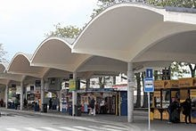
The Grand Hotel bus station – Autobusové nádraží u Hotelu Grand is located very close to the main railway station (see the map above). You will only have to walk 5 minutes to get to the public transport stop “Hlavní nádraží”. Check how to get to your dormitory section below.

FROM ZVONAŘKA BUS STATION
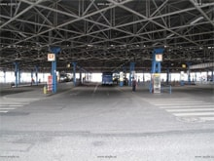
The Zvonařka bus station is located further from the city centre (see the map above). In order to get to the city centre, you will have to take bus number 40, 48, 50, or 63 and get off at the “Hlavní nádraží” stop. Alternatively, you can walk there, which takes about 10 minutes. You can continue to your dormitory from there.
For more information on ways from/to Brno, and from/to the airport – see the website of the South Moravian Integrated Public Transport System and the travel planner.
You can also find other possibilities of getting to/from Brno from different cities on this useful website.
You can check the timetables of public transport in Brno here.
Czech online maps are available on this link.
Or you can ask your tutor to pick you up at the station and go by public transport together to the accommodation (it takes only about 15 minutes by tram).

>> See also How to Get to Your Dormitory.

