Private Accommodation

Brno City
Brno is the second largest city of the Czech Republic. It is located in region South Moravia. It was a main center of industry in the past. These days it is a science and a technology city.
City of Brno is divided into 29 city parts. CEITEC is located in several of them. Campus of Masaryk University is in Bohunice, Technological campus of Technical university is in Královo Pole. Some of others main buildings are in part called Střed.
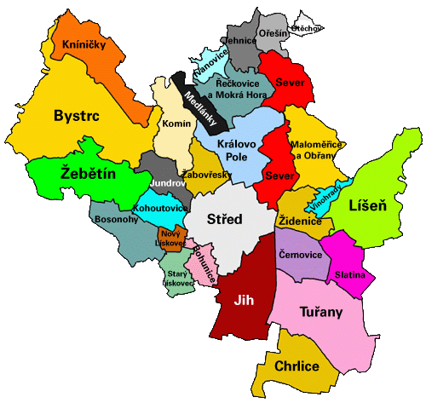

Renting Accommodation
Renting a property is one of the basic concerns when you move abroad, and it can be a serious challenge, because laws and customs differ widely from country to country. The system here in the Czech Republic may involve a few features which you are not familiar with, but in general the real estate scene is not overly complicated, and many regulations and restrictions have been eased in recent years.

Most foreigners – at least when they first arrive here – opt for renting a flat or house. Rental practices here have a number of features that you should be aware of.

Who to deal with

It’s best to deal with a reputable agency. While individuals also can and do offer flats and houses to rent, problems may arise if you decide to rent from a private individual, particularly when it comes to obtaining proof of ownership (needed for official purposes – see below). Good agencies will make sure that the person leasing the flat is legally entitled to do so, and that the lease contract contains all the necessary and standard provisions.
The usual fee (commission) charged by an agency is equivalent to one month’s rent.

The lease contract

You should, of course, be in a position to understand exactly what you are signing. Any agency accustomed to dealing with foreigners should be able to provide you with a lease contract in both - an English and a Czech version (the latter having legal force should there be any question as to interpretation). Many can also supply versions in other major international languages.

Ownership of the property

Proof of ownership of the property you wish to rent takes the form of an extract from the property register. This is an important document for two reasons.

First, only the owner (or an individual with power of attorney to represent the owner) can lease a flat or house. However, many flats in the Czech Republic are in fact owned by local authorities, and it is illegal to sublet these flats. Only an extract from the property register ensures that you are renting a flat legally.

Second, in order to register for a long-term stay with the police, you will need to show them your lease (in Czech), the extract from the property register indicating who the flat you are renting belongs to, and a declaration by the owner (“čestné prohlášení”) – signed before a notary public – that states s/he is indeed renting the property to you.

Rent and security deposit

Rent is usually paid Monthly, in advance. Rents may be quoted in one of two ways. The first is the basic rent for the flat/house alone plus, separately, the cost of the utilities (electricity, water, gas). The second is an overall rent inclusive of the utilities. You should make sure, when a particular rent is quoted, which of these two systems it reflects. If the utilities are calculated separately, their approximate cost per month is then added to this basic rent to make up the rent you will actually pay each month. (This will be stated in the lease contract.) Once a year the landlord will calculate your real consumption of electricity, water and gas;
depending on the results, you will either receive a refund or be required to pay an additional sum to make up the difference. Usually the lease also includes a provision for a security deposit, in most cases equal to one month’s rent. This is paid at the beginning of the tenancy, and kept by the landlord to be returned at the end

of the period of occupancy, unless some damage has been caused to the property. In this case, the landlord can retain part or all of the security deposit to cover the cost of repairing the damage.

Hand-over protocol

The lease, or (more often) a protocol attached to it, may contain such things as a description of the state of the flat, its contents, the state of the utility metres, etc. The latter in particular is important. You should check that the figures listed for the metres correspond to the reality; otherwise, you might be in for a big surprise when the annual calculation of your consumption of electricity, water and gas is made. The same is true of the description of the flat; you do not want to be held responsible for damage that was actually caused before you started renting the place, or be accused of having made off with something that was not there in the first place.

Duration of the lease

Most leases are signed for a period of one year. They may have a clause allowing the lease to be terminated early, in which case the notice period can vary from one to three months. Otherwise, Czech law states that in cases where you wish to break the lease early (or where no termination date has been specified, though this is uncommon, especially in leases for foreigners), you must give three months’ notice.

Pay attenttion

Since there is a new Civil Code, that allows to make verbal contracts, you can use it for faster agreements (in case your landlord is away and you need to make some changes). Usually this part of your agreement would be added to the written one as soon as it possible. But it has not to be the case. Also verbal agreement is binding same way as the written one.

Other possibilities for private accommodation:
- Domeq
- Flats / Shared rooms for rent
- City Real Estate
- Centre for Foreigners JMK - accommodation
- Foreigners
- Flat Rent Brno
- forStudents
- Hostel Jacob
- SReality
- Flats in Brno

